Generation Y In Canada: Why Can't They Get a Break?
04/05/2013 03:49 EDT | Updated 06/05/2013 05:12 EDT

We pay more in tuition, have higher and more profound rates of student debt and are faced with higher costs of owning a home -- all of this while our income and purchasing power is worse off.
In the opening episode of HBO's Girls, Lena Dunham's character, Hannah, is confronted by her parents who refuse to pay her bills anymore. Hannah, a 20-something who has been interning unpaid for over a year, argues that it's a tough time for job-seekers — especially youth.
Hannah's arguments don't do anything to convince her parents to change their minds -- especially her mother, who thinks Hannah is spoiled.
And that's a point that comes up a lot now -- that kids today are spoiled. We've got it lucky. We're taking too long to grow up. We're living off of our boomer parents. We don't know what we want to do in life.
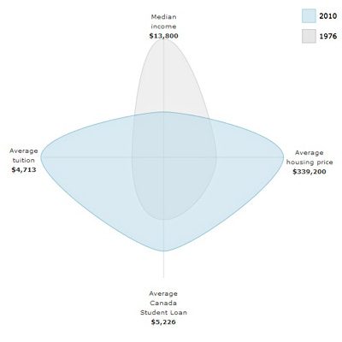
But is this really true or does Hannah Horvath have a point?
A (long-researched) article by Rob Carrick in the Globe and Mail found that "people aged 20 to 24 years are 41-per-cent worse off financially than their counterparts were in 1976."
The wide blue shape means we're screwed.
We pay more in tuition, have higher and more profound rates of student debt and are faced with higher costs of owning a home -- all of this while our income and purchasing power is worse off.
Now keep in mind that this report is based off of Canadian statistics -- about Canadians. But it's important to remember that Canada actually fared better during the Great Recession. The U.S. lost a hell of a lot of jobs during the Great Recession (8.8 million, according to the Department of Labor) and finding work hasn't been easy.
And with robots poised to steal any of your fallback jobs (sorry, Hannah, no more coffee shops for you), it's only going to get worse.
But is it all bad for 'Merica? Author Rob Carrick:
"My understanding of what's happened in the United States is that it's much tougher for young people. But at least your housing market has crashed. Makes it easier to buy than here in Canada, where prices have stayed strong."
Not very reassuring.
Sure, maybe houses are cheaper than before the crash, but who can afford mortgage payments when you're digging yourself yourself out of student loans (up to an average of $27,000) with your minimum wage job?
The Canadian Millennial: Survey Says
People are slagging on millennials for not getting their act together, but the truth is that our economic reality is much more difficult than 20 or 30 years ago. The New York Times' Annie Lowry points to a recent report from the Urban Institute:
"The average net worth of someone 29 to 37 has fallen 21 per cent since 1983; the average net worth of someone 56 to 64 has more than doubled. Thirty or 40 years from now, young millennials might face shakier retirements than their parents. For the first time in modern memory, a whole generation might not prove wealthier than the one that preceded it."
Benjamin Tal, deputy chief economist at CIBC World Markets, says that one good thing is that millennials are attending college. Sure, we're more educated, but not necessarily in the right way. The Globe article continues:
"Another issue is a mismatch between the skills and education young people are acquiring in their postsecondary educations and what's needed in the work force." Tal uses the phrase "people without jobs and jobs without people" to describe this situation.
It's depressing that after years of college you're told that you don't have the skills anyone is looking for. Almost every Gen Y'er that I know wants to buy a home, wants to save for retirement and wants to be responsible with their money -- trouble is we just don't have any.
By Chris Aung-Thwin

