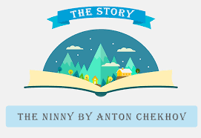
Your favorite short story

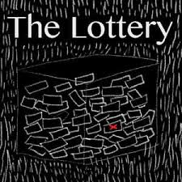
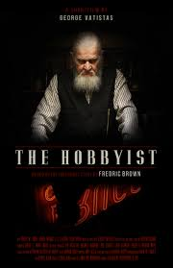
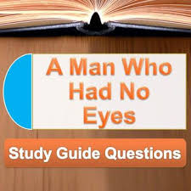
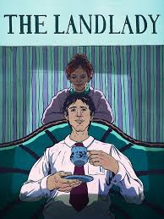

What is your favorite short story in Grade 10 and why?

STEP 1
My favorite short story this year is: ________________________________________

Possible reasons……
- It is a fascinating tale of inherent human frailties.
- It shows that the world is never black or white, always shades of grey.
- It is 'narrated' by an observer who cannot remain impartial though he does not get 'into' the story.
- It has a delightful twist.

Have you notices that all the reasons are in 3rd person point of view?

Make sure that your reasons are also in 3rd person!

STEP 2

My 3 POINTS or reasons:
P
- __________________________________________________________________________________________________________________

P
- __________________________________________________________________________________________________________________

P
- __________________________________________________________________________________________________________________

STEP 3

Prove your points with EVIDENCE (facts from the short story).
Be precise.
E
- __________________________________________________________________________________________________________________

E
EXPLANATION how the EVIDENCE supports your POINT
__________________________________________________________________________________________________________________

E
- __________________________________________________________________________________________________________________

E
EXPLANATION how the EVIDENCE supports your POINT
__________________________________________________________________________________________________________________

E
- __________________________________________________________________________________________________________________
E

EXPLANATION how the EVIDENCE supports your POINT
__________________________________________________________________________________________________________________

STEP 4

Don’t forget …….
The opening sentence (simply introduces your topic/POINT)
________________________________________________________________________________________________________________________________________________

The closing sentence (simply wrap up your topic/POINT)
________________________________________________________________________________________________________________________________________________

STEP 5

Don’t forget to use linking words and transitional devices!
Make a list!

STEP 6

WRITE YOUR DRAFT COPY
STEP 7

CORRECT IT!

STEP 8

HAND IN YOUR FINAL COPY WITH A TITLE PAGE
Due dates:

October 5, 6, 7, 8, 9: choose your story and brainstorm

October 10: Choose your 3 points, 3 examples (PEE)
Fill in the blanks.

October 11: Choose your 3 explanations (PEE)
Fill in the blanks.

October 12: start your draft with opening and closing sentences
Fill in the blanks.

October 15: correct your work, type 12 font, double space, title page

October 16: DUE DATE
You do not have that period to work on it.

