That Was Then, This Is Now
By: S.E. Hinton
CHARACTERS:
Bryon Douglas:
- a 16 yr old boy who is experiencing both physical and emotional changes
- the story is told in the first person (through Bryon’s eyes)

Mark:
- Bryon’s best friend
- Mark has lived with Bryon and his family since the death of his parents

Cathy Carlson:
- M&M’s sister and _____________________ girlfriend

M&M Carlson:
- Cathy’s younger brother

Charlie:
- Owner of the neighborhood bar
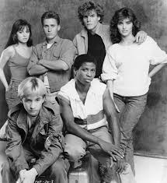
Angela Shepard:
- Bryon’s former girlfriend

Curly and Tim Shepard:
- Angela’s brothers

Mike Chambers:
- Victim of a savage beating

THEME:
- Deals with the concept of selflessness (which produces maturity)
- The characters learn the truth about growing up.

