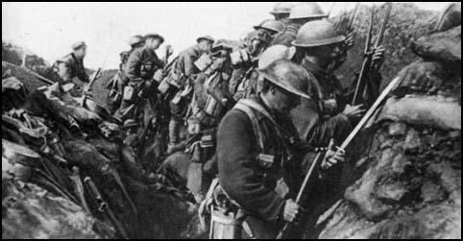
The Bayonet was a psychological tool. Added to the front of a standard issue rifle, it was to be used in cases of close combat. But the trenches rarely allowed for close combat (soldier-to-soldier). Bayonets were used to stoke the fire and pick lice from the seams of a soldier’s uniform in the trenches.

“Copping a packet”
The horrendous nature of death in industrialised conflict was reflected, possibly in an attempt to cope with it, by numerous creative ways of avoiding saying "killed": for example, becoming a landowner, going home, being buzzed or huffed, drawing your full issue, being topped off, or clicking it.

“Narpoo”
From the French il n'y a plus, meaning "none left", this phrase was one of the most familiar of the war, used to indicate a sense of failure or mediocrity, "finished" or even "dead". It could close a conversation in any indefinite way, or describe the way the Allies feared the war might end. For German soldiers a naplü was a beer, and a naplüchen a cognac – clearly alcohol was in short supply on that side of the front.

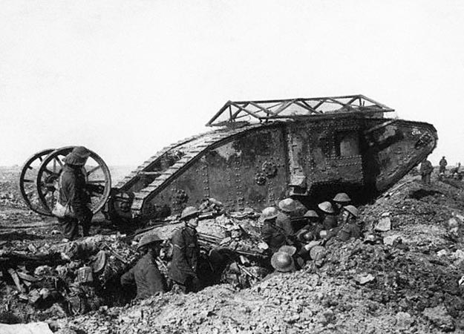
The tank was a new invention in World War I battle. They were first used by the British. They were designed to cross trenches and plow through barbed wire and other obstacles. Their metal armour protected them from machine-gun fire and shrapnel (the pieces of metal that spray in all directions when artillery shells explode). Tanks often broke-down or got stuck in the mud of the battlefield, but the technology was quick to improve and develop.

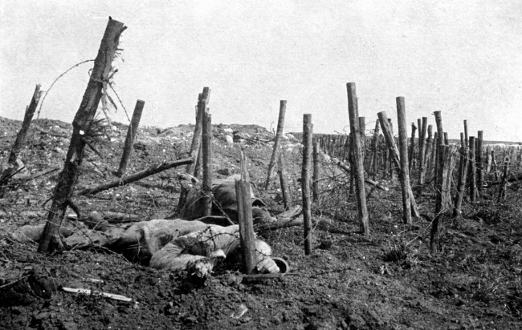
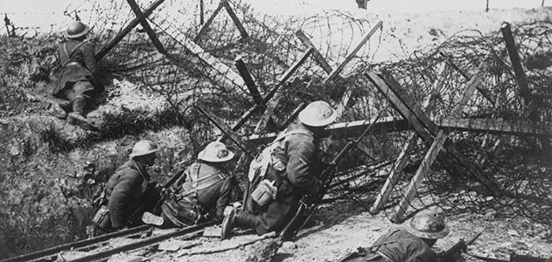

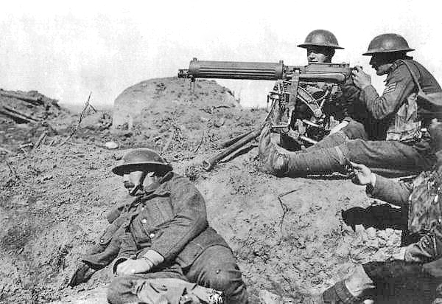
The German forces had better machine guns when the war began (they had developed the Maxim machine gun for conflicts in Africa at the end of the 1800s). This is why so many Allied soldiers were gunned down as they tried to cross no-man’s-land. Machine-guns could fire between 400 and 600 rounds per minute.
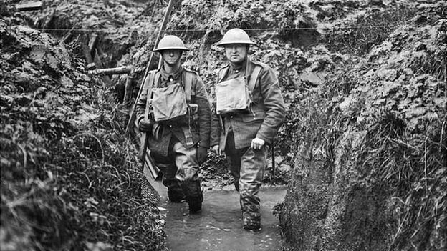
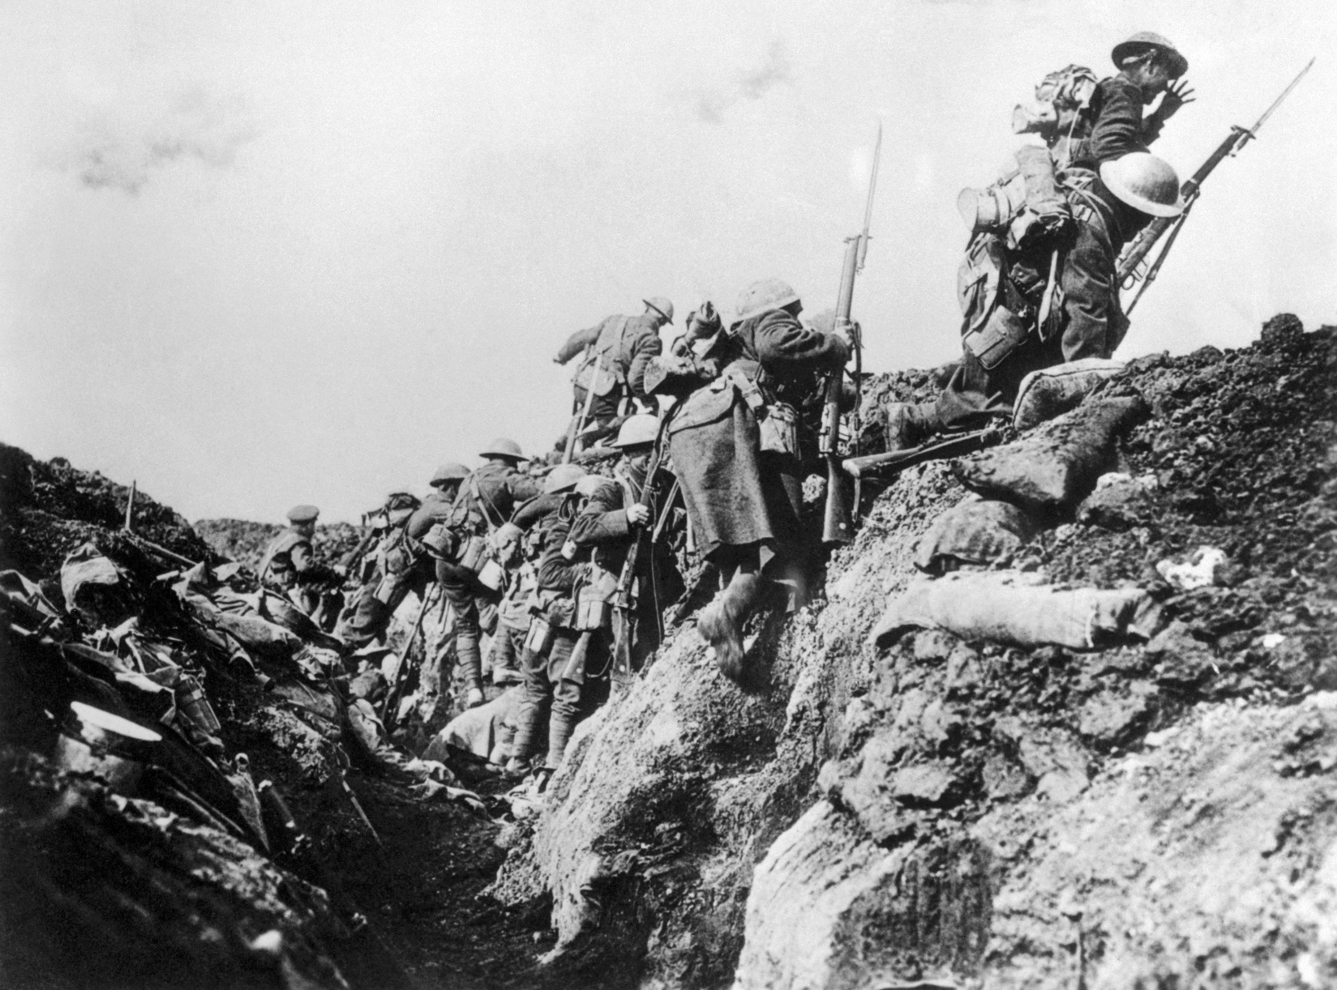

John William Law. Regimental # 55086, 19th Battalion. Born in Toronto on March 26, 1892, Law was working as a clerk when he enlisted on Nov. 7, 1914. He served overseas for five years, first in the Army and then joined the Royal Flying Corps in 1917. He survived the war and returned to Canada in 1919.

Dec. 12, 1915
Belgium
My Dear Mother and Father:
I see you are having snow at home. Oh what a pleasure to see it instead of the rain and sleet. The weather here seldom freezes, but one day in the trench everything froze up, and it was a pleasure to be in that day to feel the solid ground under your feet once more, but the next day melted and the mud from then on has been knee deep … I wonder will they have a truce like they did last year. Seeing I can’t be with you I am looking forward to spending Christmas in the trench in the hope that there is a truce. At times the Germans are very quiet, sometimes hardly a rifle shot, and at other times, when a different battalion are in things are livelier … Here I am with a candle on a box of a thousand rounds of ammunition, the gun two feet away, a little coke fire that took all day to get going at my feet, two comrades at my back snoring and sleeping their heads off, with their stomachs full of Quaker Oats and Oxo made on the above mentioned coke stove. In a halfhour I’ll wake one of them tell him to get on guard and take my place, while I crawl under his blanket. I know he’s lousy and all that, but I guess I am, too.
Will close now with Best Wishes to you all for a very Merry Christmas and a Bright and Happy New Year.

Your loving son, John

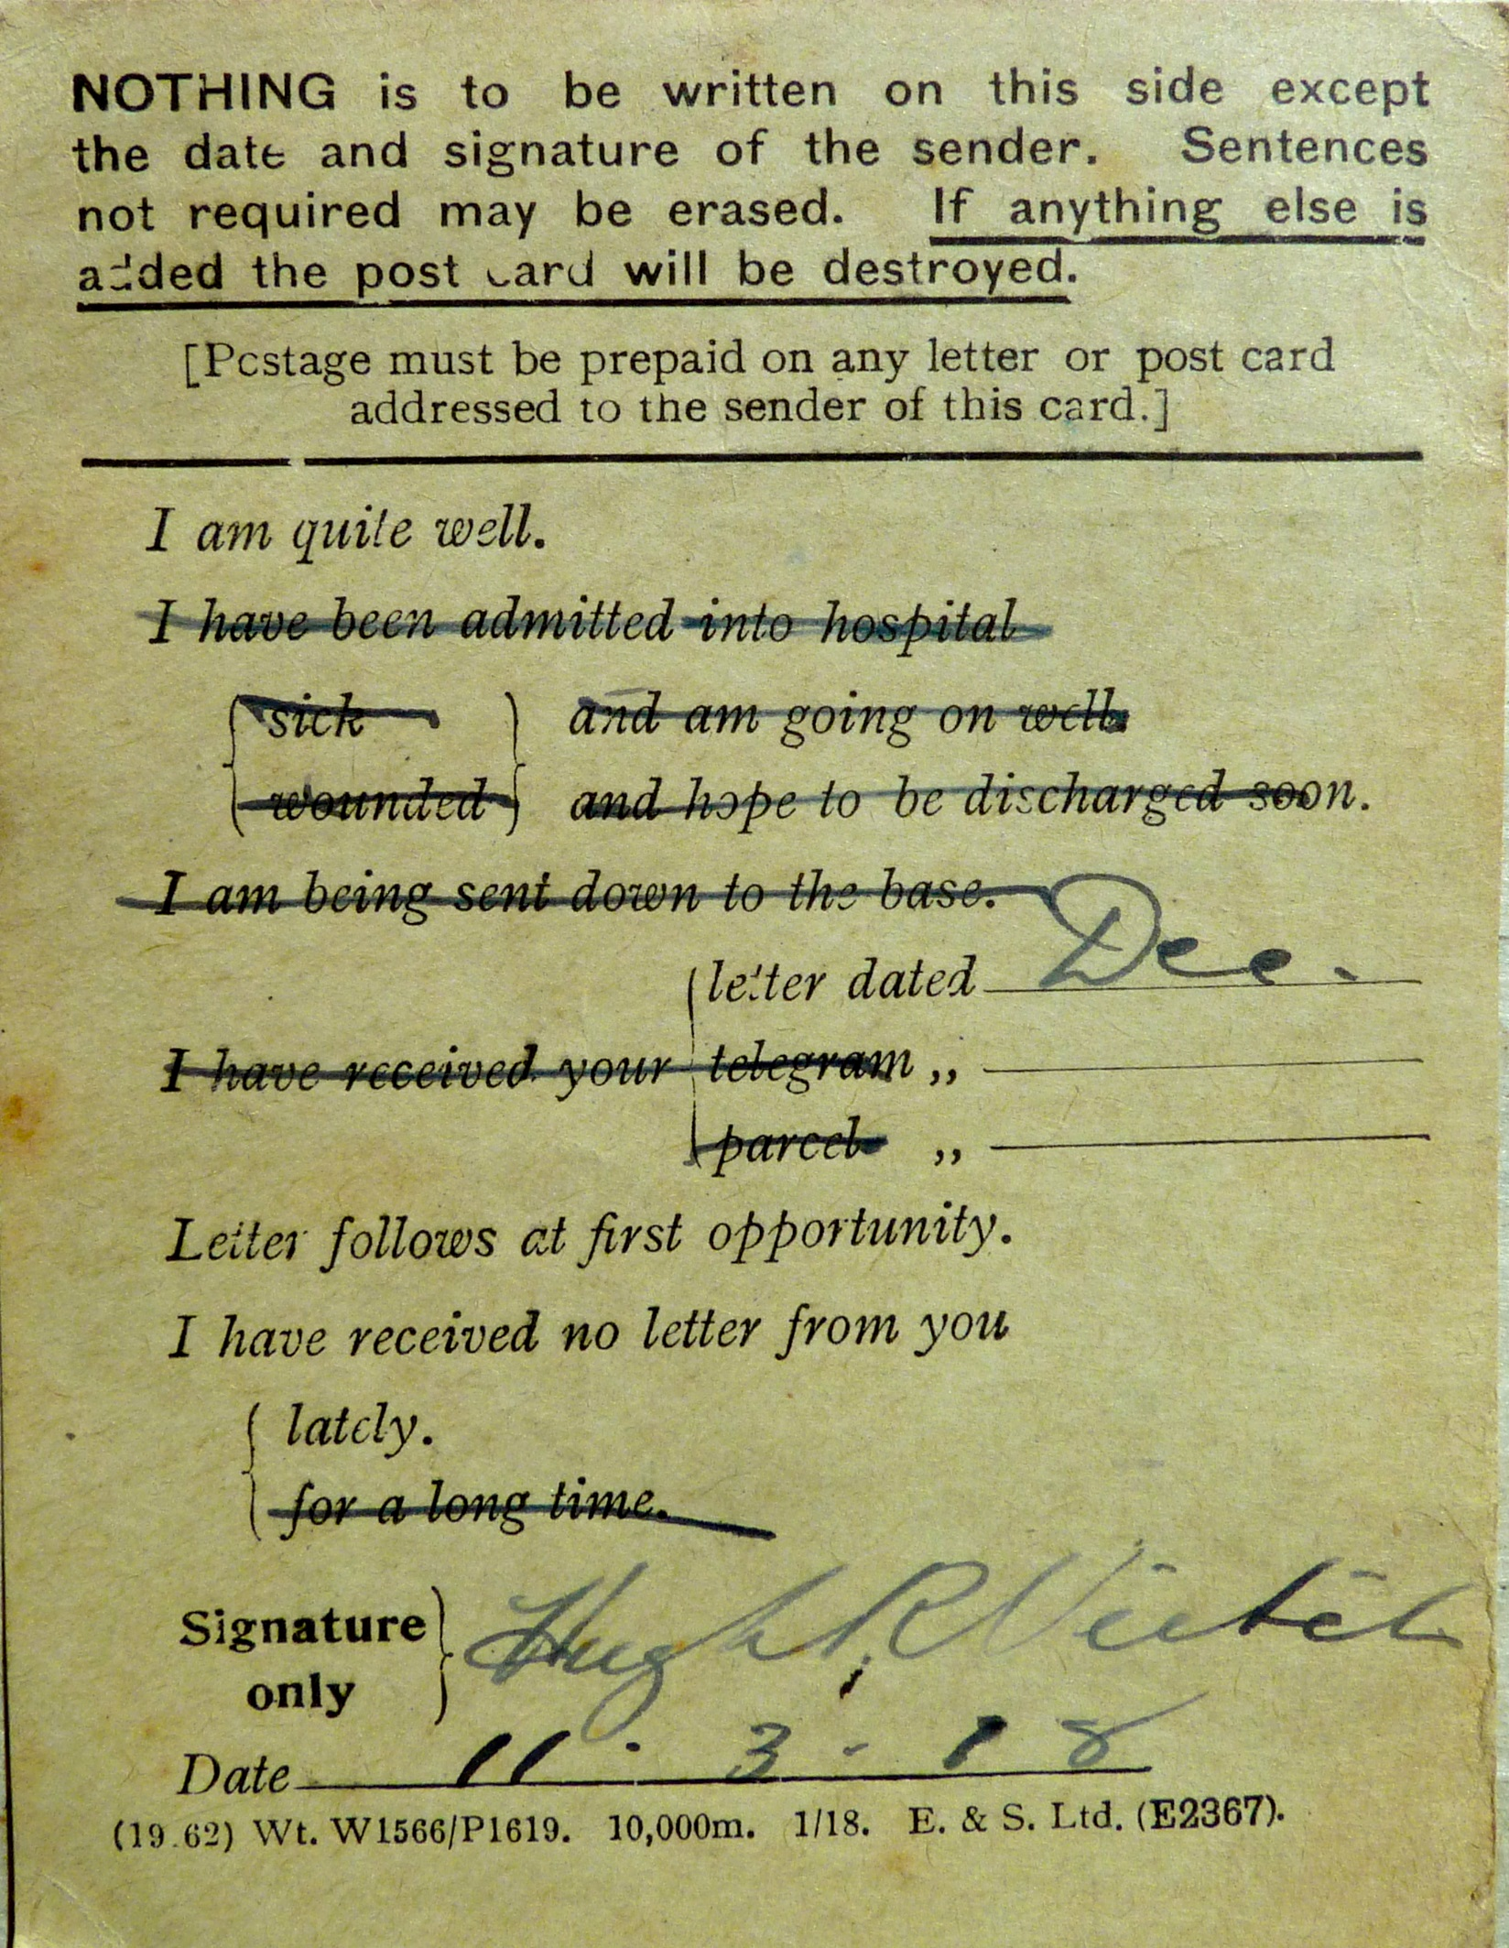
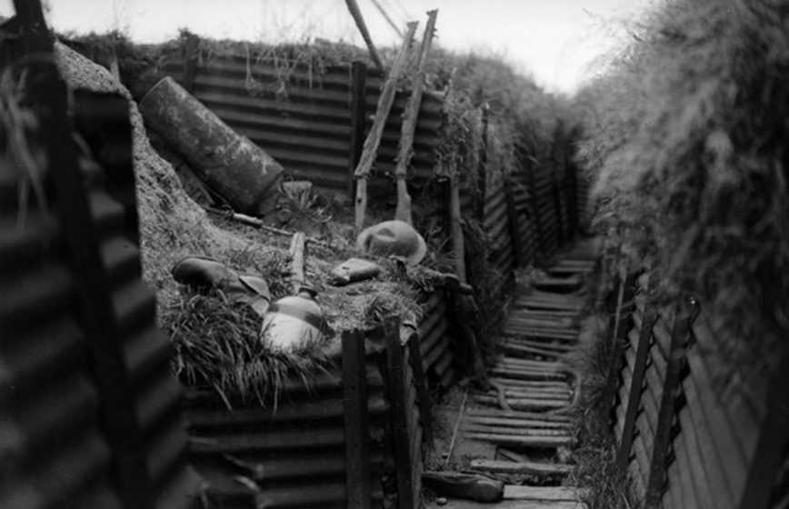
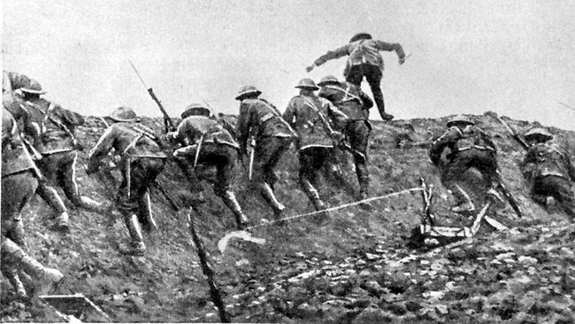
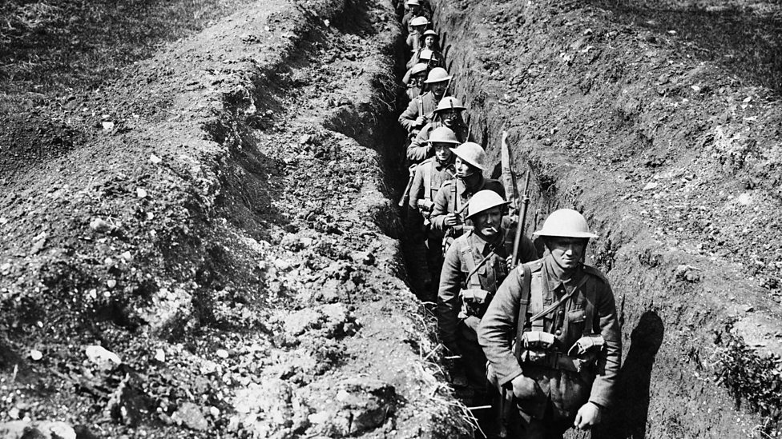
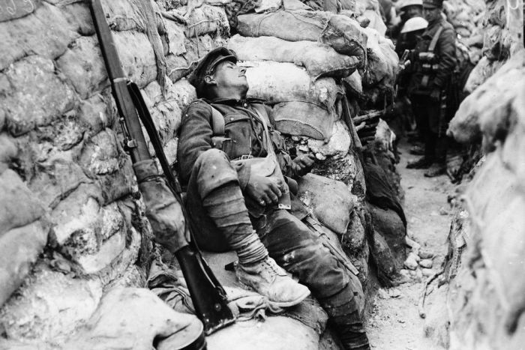

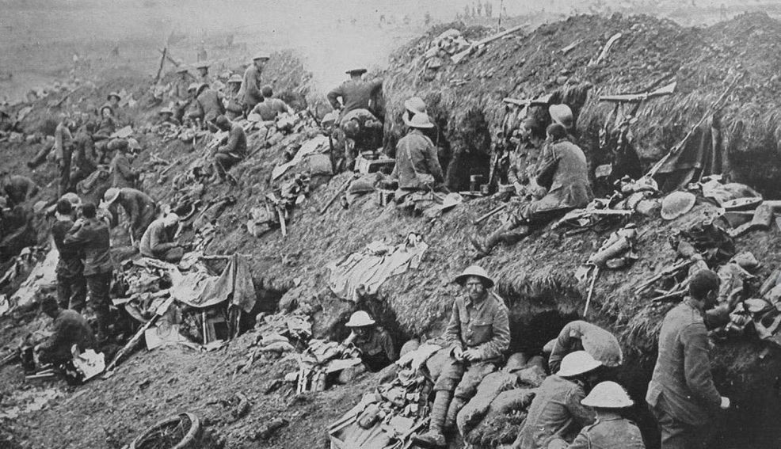
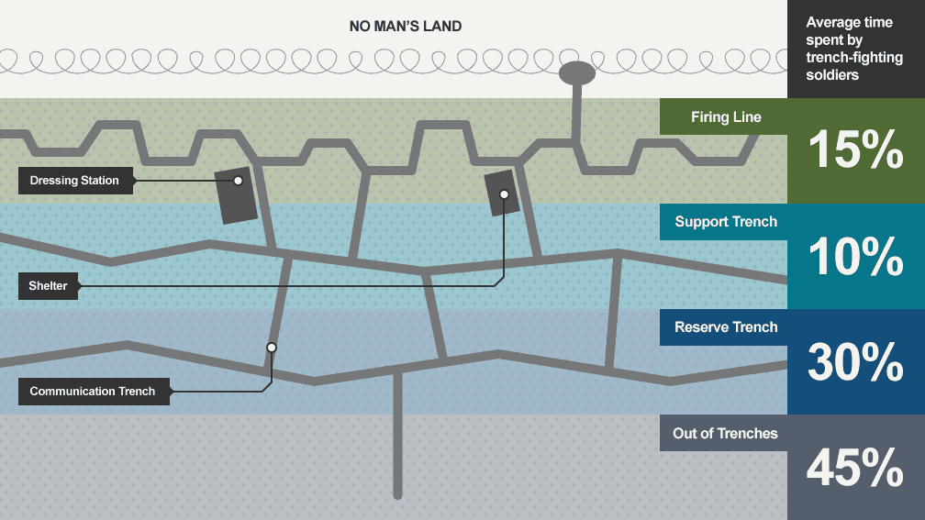

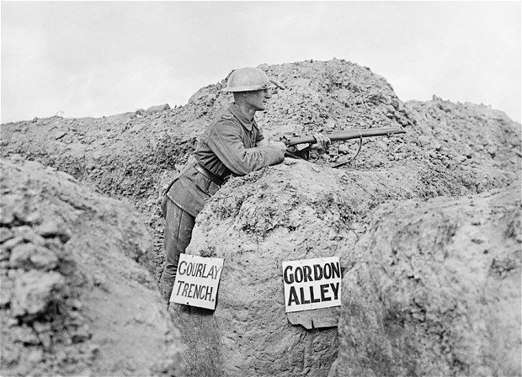
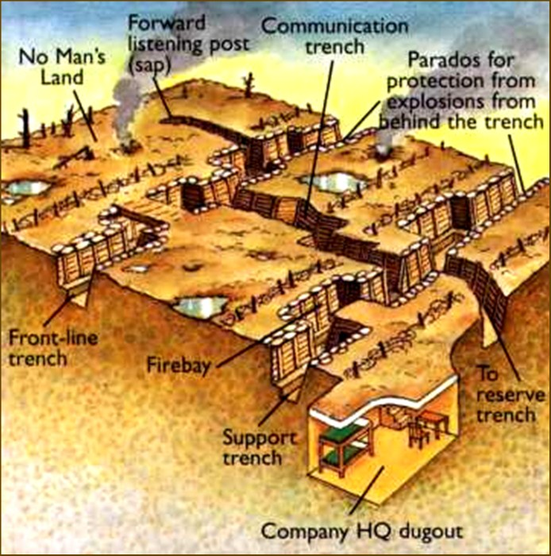
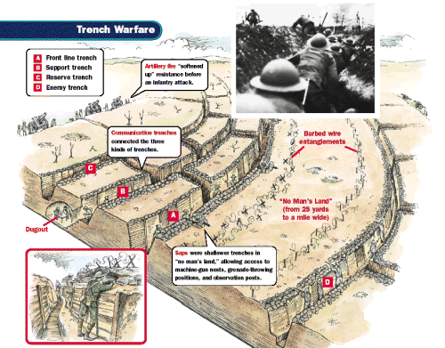
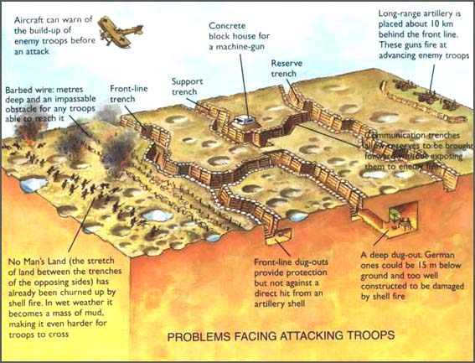

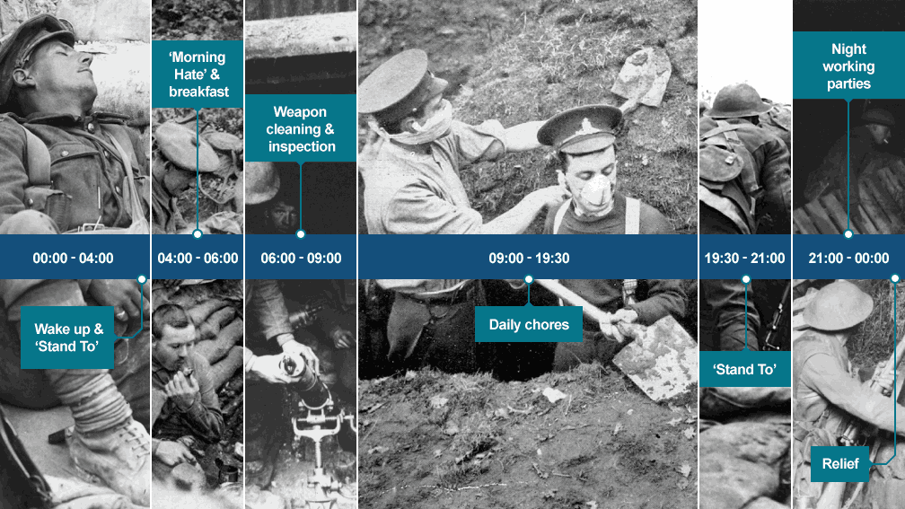
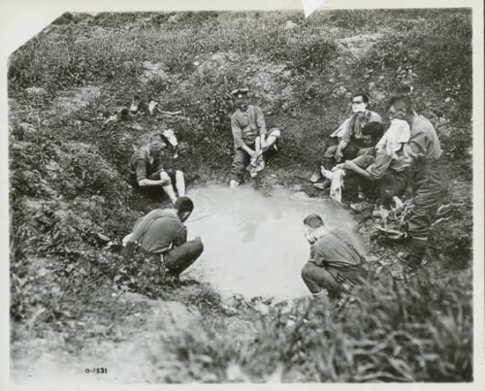
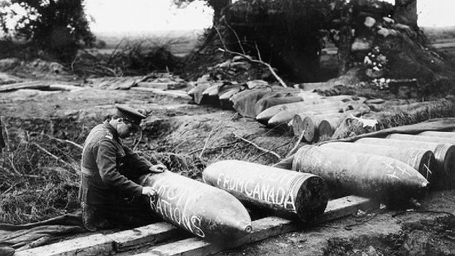

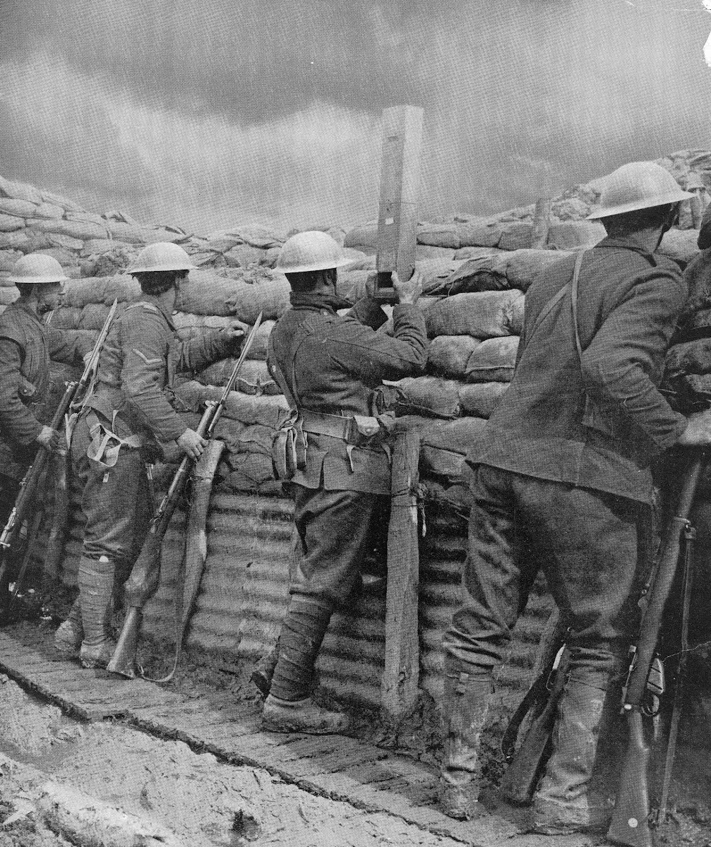
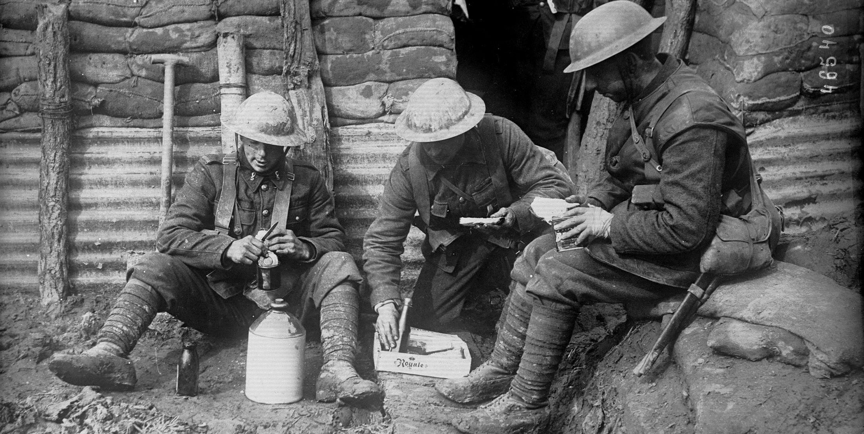
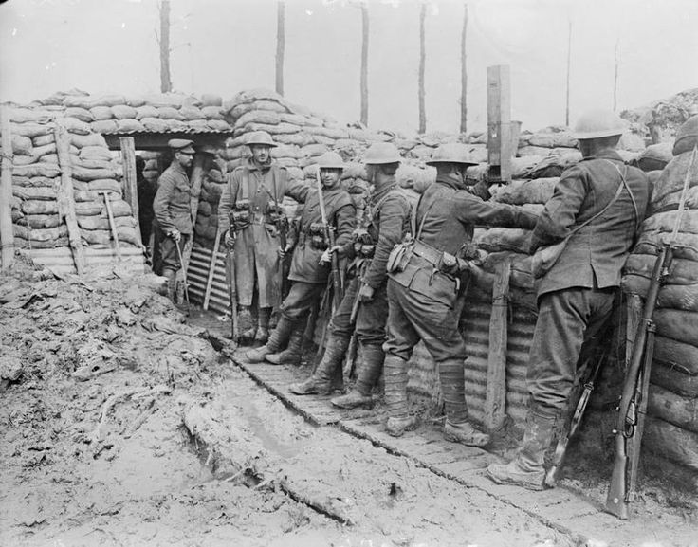
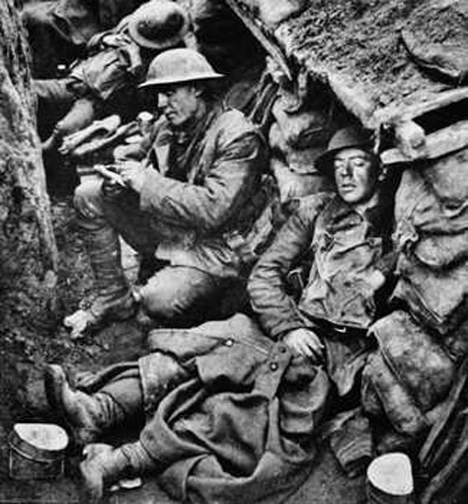

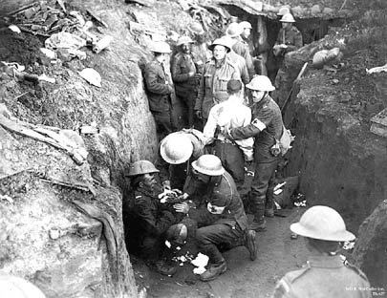
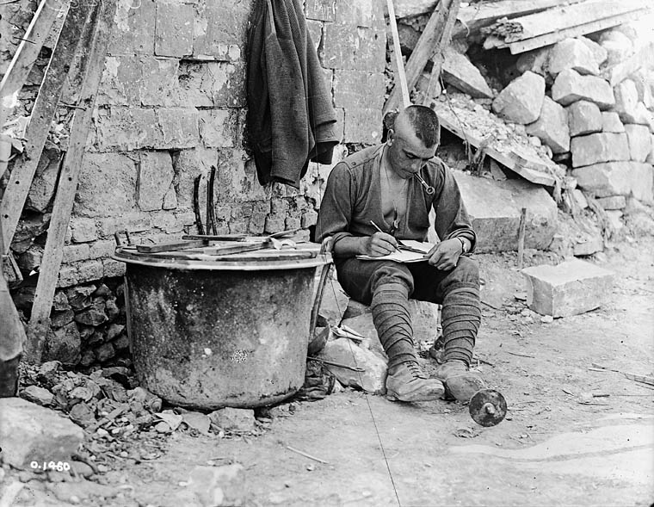

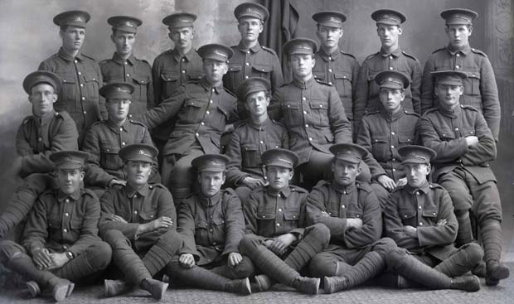
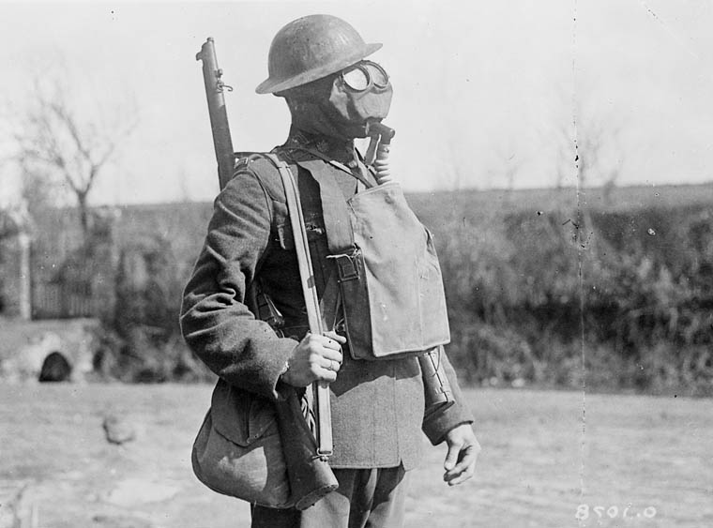
Many poison gasses were used for the first time in World War I. Chlorine gas (the most deadly) was used by the Germans. It burned the eyes and lungs, causing victims to choke, gag, and suffocate to death. Both sides equipped their troops with gas masks, because both sides used poisonous gas. In the end, gas attacks were not very effective as they relied on prevailing winds to carry the gas toward the enemy.
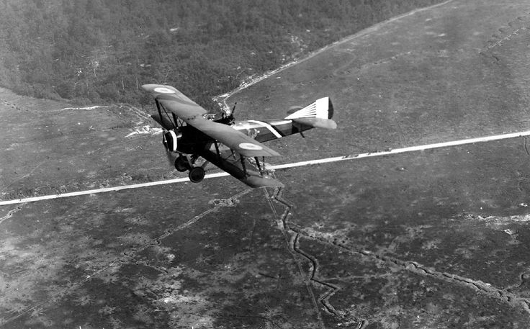
Airplanes were initially used for reconnaissance (spying and gathering information of enemy trench activity). By the end of the war, airplane technology had improved tremendously. Special fighter aircraft had been designed to shoot down enemy planes, or to carry bombs. Fighting between planes in the air was called a “dogfight”.
