The Merchant of Venice
Final Summative Activity

The time has come to complete the final project for this unit – and you will have some choice in which activity you complete for this assignment! Choose one of the 4 activities outlined below, to demonstrate what you have learned in your study of William Shakespeare’s The Merchant of Venice. Play to your strengths!

Brainstorm: ______________________

Rough Draft/Practice/Rehearsal: ________________________________

Revision: ________________________

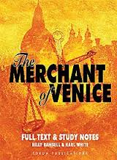
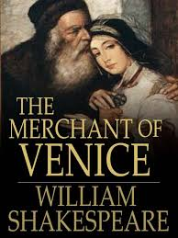
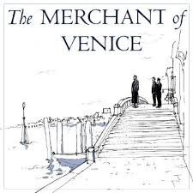
Final copy/Presentation: ________________________________

Option A – The Merchant of Venice Visual Piece

Who chooseth me shall create an artistic piece on an important scene from The Merchant of Venice! This piece can take the form of a collage, a poster, a three dimensional work, or something else, and may include drawings, paintings, computer generated images, magazine clippings, and words. Be creative with this assignment! You may choose any scene from the play that you found to be significant. You will also be required to submit a ½ page typed explanation on your piece, telling why you chose your topic, and its dramatic importance to the play. Remember, your piece must clearly indicate which scene you have chosen!

Checklist for The Merchant of Venice Visual Piece:

Thinking and Inquiry:
- Does your written submission clearly explain the purpose of your piece, and explain the scene’s dramatic significance to the play?

Knowledge and Understanding:
- Does your work present a clear understanding of the scene you chose?

Communication:
- Is your written work free of mechanical errors?
- Does your piece clearly depict a major scene from the play?

Application:
- Does your work show imagination and creativity?
- Did you take pride in your work, and how it is presented?

Option B – The Merchant of Venice Performance Piece

Who chooseth me shall perform an important scene from William Shakespeare’s The Merchant of Venice! In small groups, or individually, you will choose an important scene from the play, and perform it for your peers on the date this assignment is due. If you are working in a small group, then you might choose to perform a scene with equal roles; If you are working alone, then you might choose to perform an important soliloquy by a significant character. If the scene that you would like to perform is too lengthy, you will not be expected to perform the entire thing – Focus on the important parts! Your presentation should be about 3-5 minutes if you’re working independently, or about 8 minutes for a group. Each member of the group will also be required to submit a ½ page written piece, explaining why you chose the scene, its significance to the play, and why you performed it in the way you did. Don’t be afraid to get creative with this assignment! You may choose to perform the scene as it was written by Shakespeare himself, or translated into modern English. Bring props and costumes, and have fun!

Checklist for The Merchant of Venice Performance Piece:

Thinking and Inquiry:
- Does your performance clearly depict a major scene from the play?

Knowledge and Understanding:
- Does your written submission clearly explain your choice, and explain the scene’s dramatic significance to the play?
- Does your scene present insight into the plot, theme, and characters of the play?

Communication:
- Is your written work free of mechanical errors?
- Do your expressions and body language reflect that of the characters in your chosen scene?

Application:
- Does your work show imagination and creativity?
- Did you take pride in your work, and present it confidently?
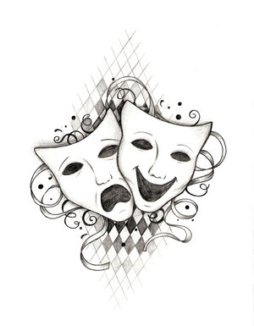
Option C – The Merchant of Venice Opinion Piece

Who chooseth me shall write an opinion piece on an important scene, theme, or event from William Shakespeare’s The Merchant of Venice! Students are asked to select a controversial topic from the play and write a five-paragraph opinion piece (intro – 3 dev – conclusion). The polished piece should be a minimum of 300 words in length, and include a minimum of 3 cited quotes or passages. Don’t be afraid to get creative with this work – you may choose to write your piece from your own viewpoint, or you may choose to write your piece from the viewpoint of someone living in Shakespeare’s time – perhaps even one of the characters from the play! Remember to consider the different viewpoints of people in Shakespeare’s time and today. Do you think that you have the same perspective today as a person viewing the play in the 1500’s would have? Step into the shoes of the person you are writing as! This assignment should be typed, double spaced and 12 font.

Checklist for The Merchant of Venice Opinion Piece:

Thinking and Inquiry:
- Do you use specific examples and quotes (6) from the text to support your opinions?

Knowledge and Understanding:
- Does your written work show a clear understanding of the chosen topic, and its importance to the play?

Communication:
- Is your work free of mechanical errors?
- Is the essay logically organized?

Application:
- Does your work show imagination and creativity?
- Did you take pride in your work, and is the presentation neat and tidy?

Option D – The Merchant of Venice Tabloid writing assignment

Who chooseth me shall write a tabloid writing piece on an important scene, theme, or event from William Shakespeare’s The Merchant of Venice! Your issue might be a scandalous romance, the loan, a conflict between characters – or anything that follows the subject of the play.

What’s a Tabloid?
Tabloid newspapers use sensationalist writing. This means the writer might exaggerate, embellish, or even make up facts in an attempt to sell the story. Celebrity gossip magazines are an example of tabloid writing. You’ve seen this in those magazines near the cashier of stores.

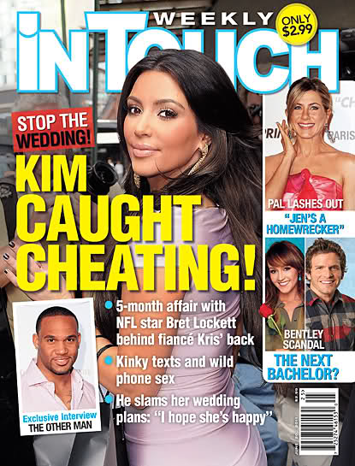
Sample Ideas
-Antonio and Bassanio in a Secret Relationship
-Jew & Christian Tear Apart Traditions
-Portia Pregnant… With Shylock’s Baby!
-Jessica and Portia Spied Together In Romantic Shocker
-Shylock Secretly Owes Millions

Success Criteria
[ ] I will include a catchy headline (front cover)
[ ] I will include pictures that represent the story or headline
[ ] I will show knowledge of major elements (character, plot, conflict, theme) of the play in my writing article
[ ] I will write in the style of a tabloid paper (See online examples)
[ ] I will insert quotes from characters who are involved
[ ] My news report will inform on the 5Ws+H (Who, What, Where, When, Why, How) article
[ ] My report will be divided into clear, effective paragraphs article
[ ] I will edit for spelling, grammar, and clear ideas
[ ] I will work to make my article appear authentic (i.e. ads on page, old-timey look, etc.)

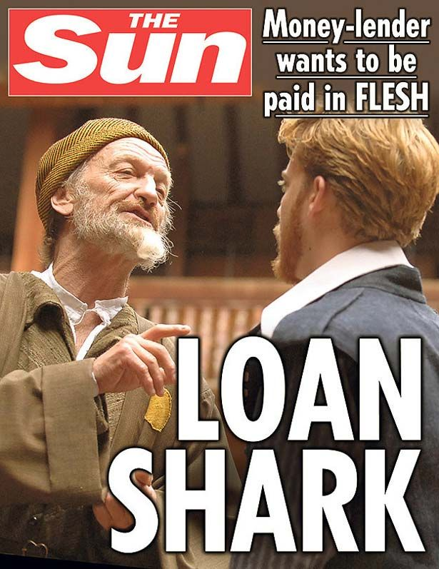
Marks – First look
Knowledge of Play Content 1 2 3 4
Style and Content of Article 1 2 3 4
Creativity Within the Article 1 2 3 4
Spelling/Grammar/Application 1 2 3 4

Marks - Follow the summative rubric provided

http://wilsonteacher.ca/eng1d-assignments/ Modified by Mme Lagrandeur

