TWTTIN

Individual Summative Project

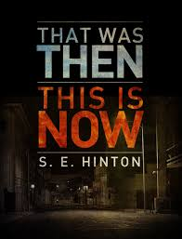
Due date: ___________________
Choose 2 of the following projects to complete.

- Write titles for each chapter and explain why you named the chapter
what you did. You should have 11 chapters with 11 explanations.
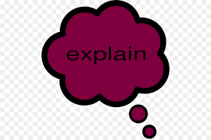
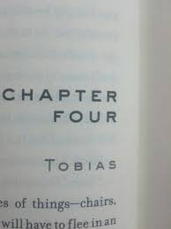

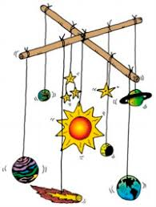
- Make a mobile of pictures that have significance in the story. Choose objects and places that symbolize important issues in the story. On the back of each, write a short explanation of the part the item plays in the novel. You should have at least 4 pictures and somehow make it into a mobile.
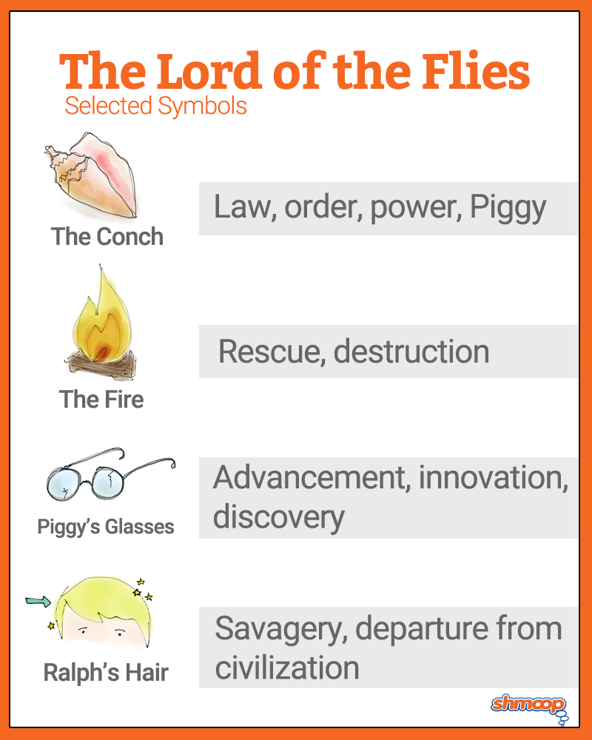

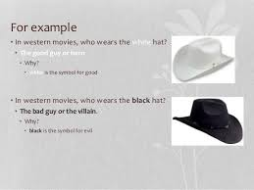
- Create a movie poster for this novel.
- You need to have the title.
- You need to have a picture or pictures.
- Invent a creative slogan for the ad campaign.
- You need to select a cast (minimum 4 actors) to play the characters from the book.
- Then write a paragraph discussing who has been selected and why you feel that person is the best actor/actress to play that particular role.

Examples:
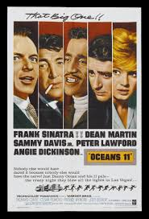
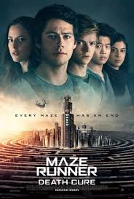

Website for movie posture template: https://www.postermywall.com/index.php/g/theatre-posters#3b90f8843aef5c1f3703328b1b838e0a
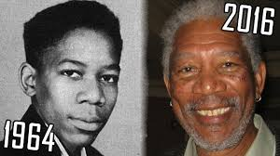
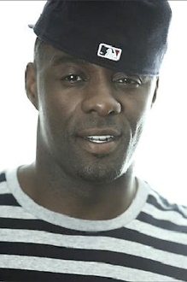
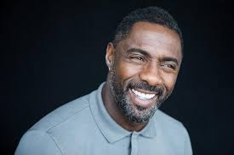

Younger Older Younger Older
Idris Elba Morgan Freeman

I strongly believe that Idris Elba would be a good choice to play Morgan Freeman. For one, they both have black skin, grey in the hair and facial hair. That deep voice that is easy to recognize, they possess it. Idris has played a variety of characters which shows his potential to play the deep/serious roles that Morgan has played. Especially………(details from the character in the novel).

