That was then
this is now

1970s
Powerpoint

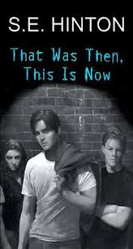
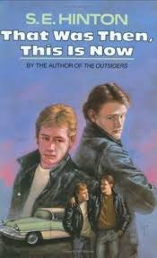
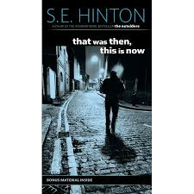

Oral presentation

Due date: ____________________________________
That Was Then, This Is Now takes place in the 1970s. To fully understand the novel, we need to step back in time to the 1970s.
Task:
- Choose 2 topics from this list - Clothes/Fashion
- Hippie Lifestyle
- Music
- Movies/Television
- Sports
- Chores
- Religion/Church
- Things that made the news/world events
- School
Content
- Research your 2 topics (info, statistics, facts).
- Identify trends and what was popular.
- In your opinion, compare 1970 to today. What has changed the most with your topics.
- Make a PowerPoint to showcase the details of your 2 topics.
- Clearly explain what your topic is (short sentences/point form).

Visual presentation
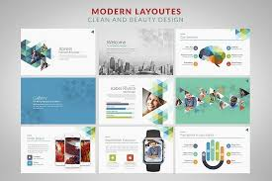
- Title page with your name/title/2 topics
- Include pictures/visuals aids that will enhance your presentation.
- Use appropriate fonts, colors and size.
- Keep track of all your sources.
- You must have a bibliography.
- Use your own words. Plagiarism will not be tolerated.

Oral presentation
- Eye contact with the audience (not staring at the screen, page).
- Good volume.
- Pronunciation/enunciation is clear.
- Good pace (steady rhythm, not too many pauses and not too fast).
- Practice is obvious.

Presentation dates at random
First day | Second day | Third day

