Cue for Treason
Summative assignment
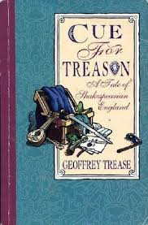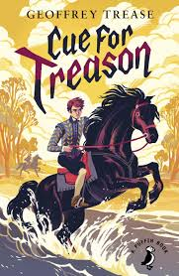
Name : ________________________________

Assignments | Tentative dates
Individual : Map of England | April 29, 2016
Individual : Create a soundtrack | May 3, 2016
Individual : Letter writing | April 20, 2016
Individual : Short essay | May 25, 2016
Individual : Bonus activity - crossword | April 14, 2016
Group : Newspaper | May 9, 2016
Group : Quiz | May 9, 2016
Cue for Treason
Summative assignment
PART A: Individual Assignments
Each student must hand in all Part A assignments together in a duo tang/binder/folder.

- MAP OF ENGLAND—
List all the counties, towns, villages that are mentioned in the novel. Create a legend to indicate areas that Peter and Kit visit while with the acting troupe, areas where spies were and Kit and Peter’s homes.
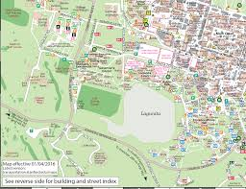
Characters | Areas (counties, towns, villages)
Peter’s home(s)
Kit’s home(s)
Peter and Kit with the acting troupe
Spies were

- CREATE A SOUNDTRACK—
Choose 5 modern songs that you believe could be used as a soundtrack to the novel (think: theme, story plot, characters, etc). Explain why you chose each song (3-5 sentences per song). Make sure I have the title and artist of your songs. You can make a list of youtube videos of these songs or you can burn a CD.

- LETTER WRITING—
Writing as Peter, reply to the letter from his mother. Letter should be at least three paragraphs long. (5-8 sentences per paragraph – use the friendly letter format)
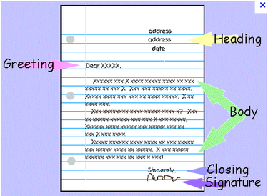

- SHORT ESSAY WRITING—
In a short essay of two or three paragraphs (7-10 sentences per paragraph), discuss the significance of the title of the novel. Use Chapter 16 to help support your ideas. Don’t forget your thesis statement. I will spend 2 weeks explaining the writing process.

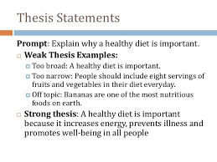

******BONUS ACTIVITY: Crossword Puzzle-- Using the vocabulary list, create a crossword puzzle with 15-20 words from the list. Include an answer key with your completed assignment.

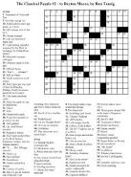
You can use this website to create your crossword:
https://crosswordlabs.com/

PART B: Group Assignment
- Each group must complete the following sections according to the chapter that is assigned.
- You will need to work as a team. This means that everyone in the group must do equal amounts of work. It is a good idea to assign within the group which parts each person will be responsible for.
- NOTE: You will not be penalized if one person in your group doesn’t do his share. Only his or her note will be affected.
Group members: _______________________________ Chapter: __________

- Design the front page of a newspaper about the events in your chapter. It should contain headlines, articles (who, what, where, when, why), drawing (as there were no cameras in the time of the novel) and perhaps advertisements (that reflect that time period).

- Create a typed quiz for your chapters. Include 10 multiple choice, 5 fill in the blanks, and three short answer questions. You must provide the answers to your quiz.

Group work for summative assignment
- Front page of a newspaper for your chapter.
- Quiz for your chapter.
Groups | Assigned chapter
Destiny & Kaylee  Christine & Kendal | Chapter 10  Sir Philip is the man
Nicolas & Noah | Chapter 12  Treason on the Thames-side
Chapter 15
The Lonely Tower

Hannah & Amelia | Chapter 16  The Heart of the Secret
Alex | Chapter 18  Striding Edge
Gillian  Brooke | Chapter 22  Virgin Mine

Characters | Areas (counties, towns, villages)
Peter’s home(s)
Kit’s home(s)
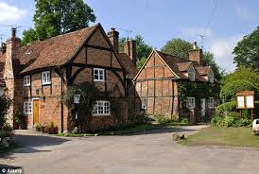
Peter and Kit with the acting troupe
Spies were

5 songs  youtube link | Song title  Artist or group | Why did you choose this song? (3-5 sentences)

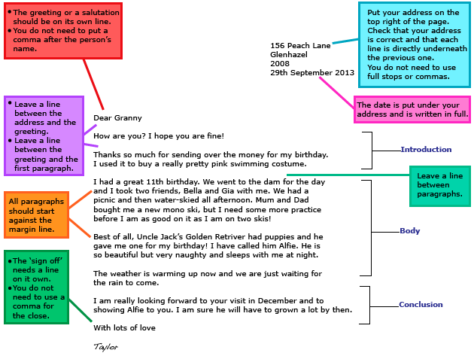
The friendly letter format

- 3 paragraphs long (5-8 sentences per paragraph)
- Use the format above

