**ACT IV**

1. What appeal does the Duke of Venice make to Shylock as the trial opens?

2. Why must the Duke legally grant the terms of the bond?

3. Why does Portia, disguised as the lawyer *Balthazar*, initially conclude that Shylock’s bond must be adhered to (granted)? How does Portia prevent the usurer from acting on it?

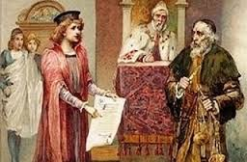

4. How is Shylock punished for threatening Antonio’s life?

5. What does the disguised Portia demand from Bassanio for her services?

6. How do Bassanio and Gratiano betray their wives?

