**ACT III**

1. Why, since it won’t result in any financial gain, does Shylock insist on the terms of his bond with Antonio?

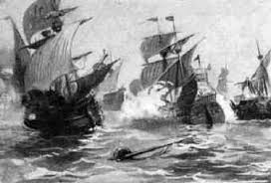

2. What news does Tubal bring Shylock?

3. Using a reference from the text, show that Shylock’s love of wealth exceeds his love for his daughter.

4. What is the effect of Shylock’s long “I am a Jew” speech?

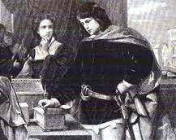

5. Why does Bassanio select the lead casket? How does this develop

Bassanio’s character?

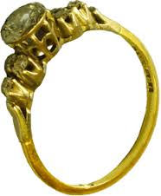6. What does Portia claim will occur if Bassanio gives up the ring she gave him?

7. According to Antonio, why won’t the Duke be able to intercede on his behalf?



8. What reply does Shylock make to Antonio’s request for mercy?

9. What does Portia decide to do at the end of Act III?

