**ACT II**

1. Why does the Prince of Morocco fear Portia will reject him at the outset?

2. What is Launcelot Gobbo’s function in the play?

3. What is Jessica’s dilemma concerning her father, Shylock?

4. How does Jessica’s letter to Lorenzo thicken the plot?

5. Before going to dine with Antonio and Bassanio, what advice does Shylock give his daughter?

6. What is ironic about Shylock’s decision to leave his keys with his daughter?

7. What are the 3 conditions of the lottery a suitor must promise before choosing a casket? **1- 2-**

**3-**

8. What is Morocco’s reasoning for choosing the gold casket over the others?

9. What is the lesson that the prince discovers inside the gold casket he chose?

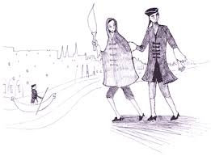10. What 2 important pieces of information are conveyed to the audience by Salerio and Solanio in Act II, Scene VIII ?

11. Why is the “Jessica-Lorenzo” subplot important to the main plot?

12. Which casket does the Prince of Arragon choose, and why?

