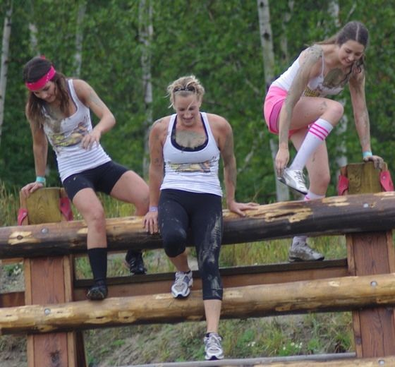
Les 2 pieds dans la boue pour une noble cause

__________________________________________________________________________________________________________________________________________________________________________________________________________________________________________________________________________________________________________________________________________________________________________________________________________________________________________________________________________________________________________________________________________________________________________________________________________________________________________________________________________________________________________________________________________________________________________________________________________________________________________________________________________________________________________________________________________________________________________________________________________________________________________________________________________________________________________________________________________________________________________________________________________________________________________________________________________________________________________________________________________________________________________________________________________________________________________________________________________________________________________________________________________________________________________________________________________________________________________________________________________________________________________________________________________________________________________________________________________________________________________________________________________________________

