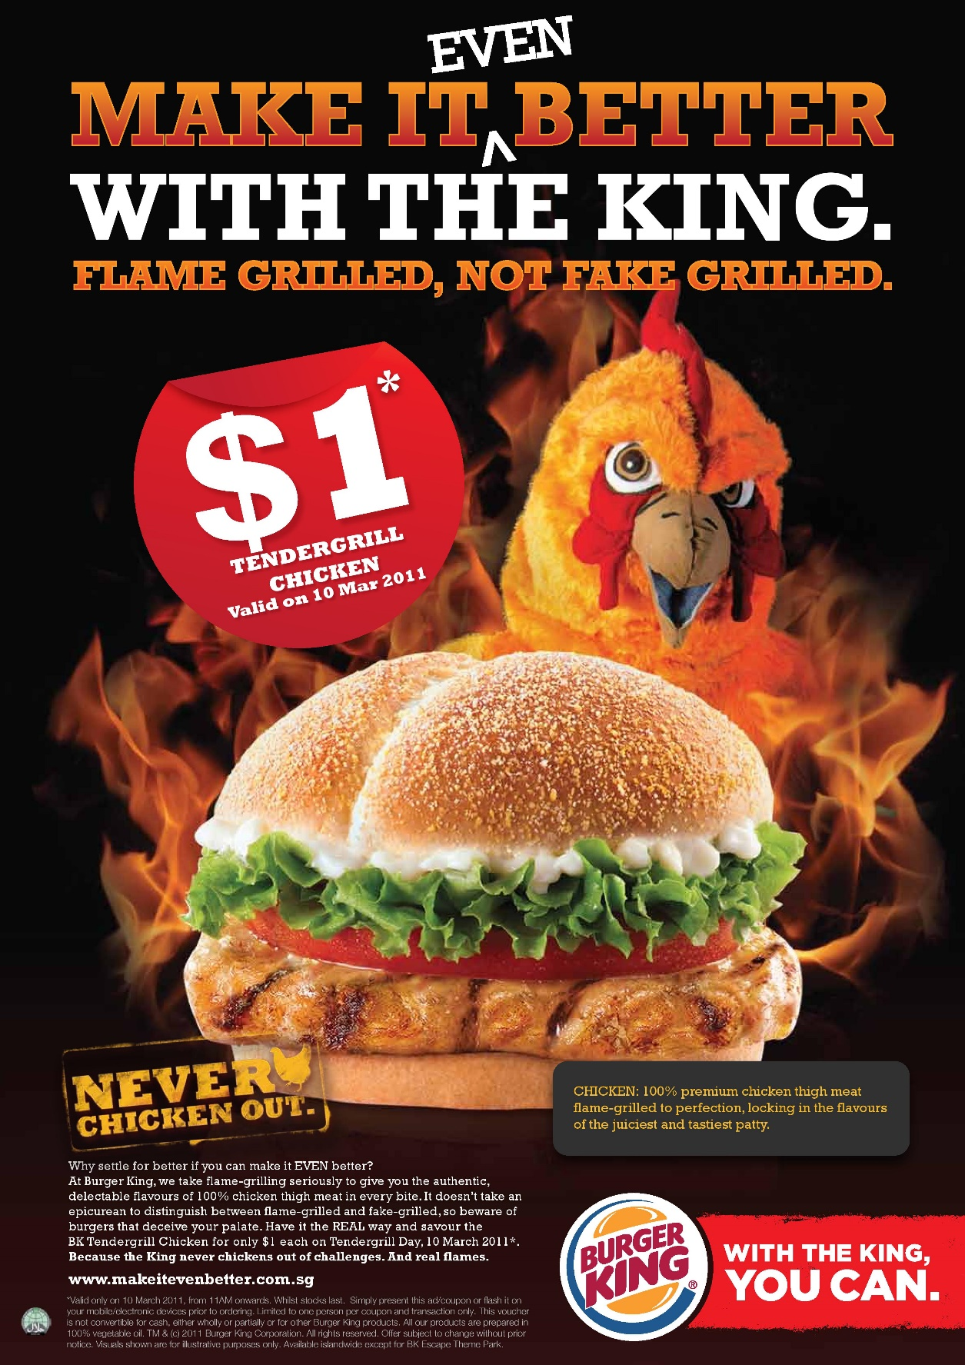
COMMON ELEMENTS IN PRINT ADVERTISING
TEXT
TEXT
LOGO
SLOGAN
IMAGE
PRODUCT
HEADLINE
TEXT

